**BMC Home Test**

Playwright: <https://playwright.dev/>

Angular tutorial: https://angular.io/tutorial

Create Angular Project that simulate shopping cart, the project should contain:

1. Registration Page with: - Email Field
   * Password field
   * Confirm Password field

* + The Email Should be valid email
  + Password length should be at least 6 letters and should contain at least 1 capital letter
  + Confirm password should be equal to the password.
  + User can not click on register button if the page is not valid.

(You can use Local Storage to store the register users)

* + Error should appear if user already exist

**Example:**

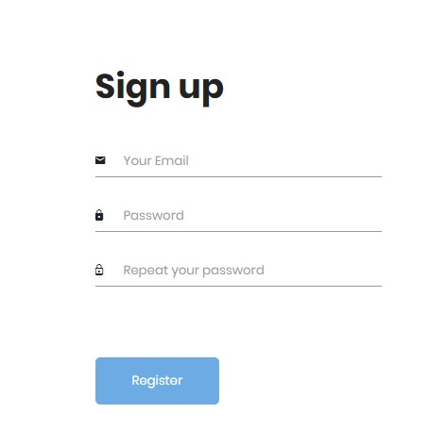

1. Registration Page test:
   * Write test plan and specified which tests should be cover the page
   * Automate the most important tests with Playwright
2. Login Page with:
   * Email field
   * Password field

Error should appear if user or password are not correct

(You can use Local Storage to store to get the list of users that was registered) **Example:**

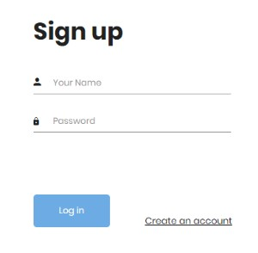

Login Page test:

* + Write test plan and specified which tests should be cover the page
  + Automate the most important tests with Playwright